Spermatogenesis

- Sperm = spermatozoa (plural), spermatozoon (single)
- Spermatogenesis = the formation of spermatozoa, occurs in the walls of the seminiferous tubules
- Gives rise to primary spermatocytes through mitosis
- Spermatogonia = immature/mother cells

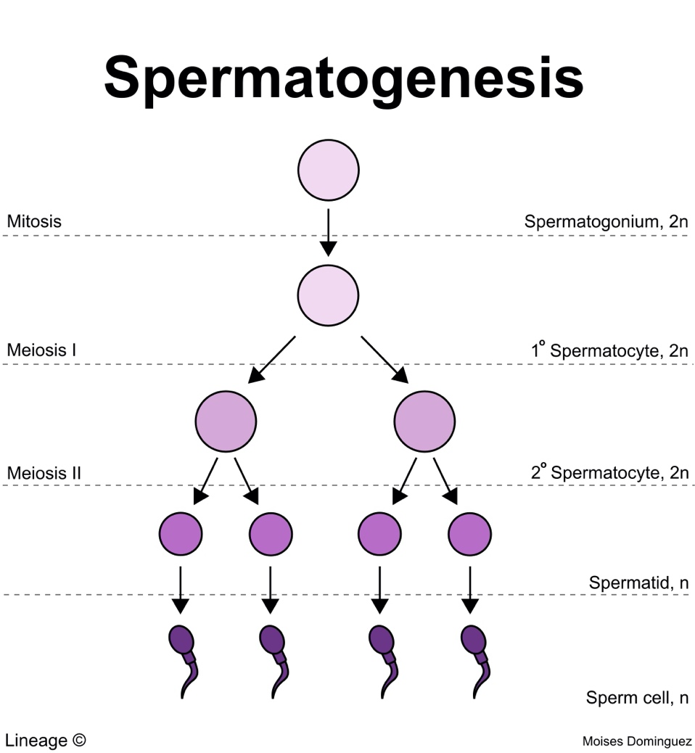
1. Spermatogonia (2n) divide by mitosis. Can become Type A spermatogonia and continue dividing mitotically near the basal lamina (outer edges of seminiferous tubule). Can also become Type B primary spermatocyte (2n). Gets pushed towards lumen or the middle of the seminiferous tubule.

2. Primary spermatocyte undergoes first stage of meiosis to produce secondary spermatocytes (n).

3. Undergoes second stage of meiosis to produce 4 round daughter cells called spermatids (n). Steps 1-3 also known as spermatocytogenesis.

4. Spermatids mature into spermatozoa/sperm. Cytoplasm of cell is lost, tail containing contractile material forms. Also known as spermiogenesis.

